Note:- |  | - The marks awarded must be printed FROM COMPUTER in black color.  - THE MARKS SHOULD NOT BE AWARDED IN FRACTION. |  |  |  |  |  |  |  |  |  |  |  |  |  |  |  | Special Examination 2022
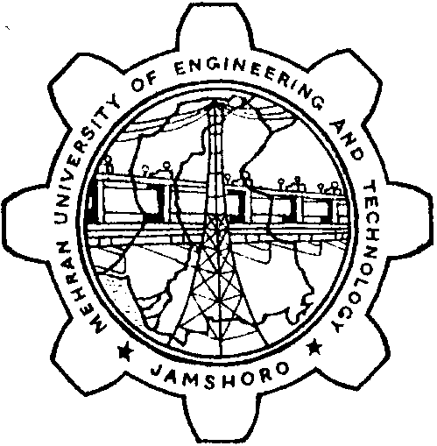 |  |  |  |  | MEHRAN UNIVERSITY OF ENGINEERING AND TECHNOLOGY, JAMSHORO |  |  |  |  |  |  |  |  |  |  |  |  |  |  |  |  | 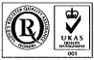
 |  |  |  |  | (EXAMINATIONS DEPARTMENT)
AWARD LIST OF THEORY
DEPARTMENT / INSTITUTE
PROGRAM
Term |  |  |  |  |  | Year |  |  |  |  | Batch |  |  | Special Exam. |  |  |  |  | Date of Conduct
Subject:
NAME OF EXAMINER
S# |  |  |  | ID Number |  |  |  |  | Attendance (10%) |  |  |  | Class Test/Assignment/  Project/  Presentation Marks (10%) |  | Mid Exam (20%) |  | Final Exam (60%) |  |  |  | Total

SIGNATURE OF CHAIRMAN/DIRECTOR SIGNATURE OF EXAMINER

IMPORTANT
The Award List Must be sent In Triplicate, Over Writing/Correction (If Any), Must Be Signed By The Examiner. The Use of Any Kind of Fluid, Eraser Is Not Permissible.

DATED:_______________________

